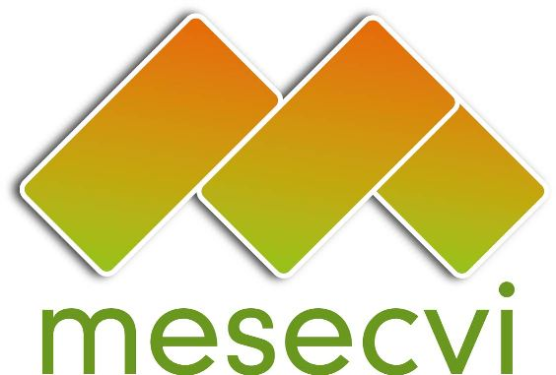


MECHANISM OF THE FOLLOW UP OEA/Ser.L/II.7.10
CONVENTION BELEM DO PARÁ (MESECVI) MESECVI-IV/doc.65/12.rev.1
FOURTH CONFERENCE OF STATES PARTIES 16 April 2012
16 April 2012 Original: Spanish
Washington DC

CALENDAR OF ACTIVITIES

(Adopted during the Fourth Conference of States Parties

held in Washington DC on April 16, 2012)

Date: April 16, 2012
Time: 8:30 to 17:30
Venue Room Padilha Vidal
General Services Building of the OAS
1889 F St. NW Washington DC 20006

8:30 | Registration of participants.
9:00 – 9:30 | INAUGURATION  Message from the Secretary General of the OAS.  Remarks by the delegate of the government of Guatemala, in its capacity as Presidency of the Conference of States Parties.
9:30 a 9:45 | Election of the officers of the Conference: Chair, First and Second Vice Chairs, and Rapporteur.
9:45 a 10:00 | Adoption of the Draft Agenda (MESECVI-IV/doc.64/12.corr.1) and Calendar of Activities (MESECVI-IV/doc.65/12.corr.1).
10:00 - 12:00 | Consideration of the Hemispheric Report (MESECVI-IV/doc.95/12), its Tables of Reference (MESECVI-IV/doc.96/12) and Final Country Reports (MESECVI-IV/doc.67/12 to MESECVI-IV/doc.94/12) of the Second Multilateral Evaluation Round.  Presentation by Patricia Olamendi, Coordinator of the Committee of Experts (CEVI).  Intervention by delegations.  Adoption of the Reports.
12:00 - 12:30  12:30 - 13:00 | Presentation of the UN Secretary-General’s Campaign “UNITE to End Violence against Women”  Ana Garita, UN Women  Report of the Technical Secretariat on the Implementation of the MESECVI (MESECVI-IV/doc.97/12).
13:00 a 14:00 | Lunch.
14:00 a 14:30 | Consideration of the draft Rules of Procedure of the Solidarity Subfund  (MESECVI-IV/doc.98/12).  Presentation by the Secretariat.  Comments by the participants.
14:30 a 15:00 | Consideration of the draft Guidelines for the Designation of CEVI Experts (MESECVI-IV/doc.99/12).  Presentation by the Secretariat.  Comments by the participants.
15:00 a 16:00 | Consideration of the draft Follow-Up to Guideline 2 of the Third Conference of States Parties: Dialogue between Competent National Authorities and CEVI Experts (MESECVI-IV/doc.100/12).  Presentation by the Secretariat.  Comments by the participants.
16:00 a 16:15 | Offer to host the Fifth Conference of State Parties.
16:15 – 17:00 | Adoption of the Decisions of the Fourth Conference of State Parties of the MESECVI (MESECVI-IV/doc.101/12).
17:00 – 17:15 | Other business.
17:15 – 17:30 | Rapporteur’s Report of the Conference.
17:30 | Closing of the Conference.
input.doc

